*Q: What are the lower, upper and total bandwidths of A for any n? Explain. What is the (exact) number of nonzero entries in A in terms of n? Explain.*

As checked using the script, the **lower bandwidth of A is 3, the upper is 4 and total is 3+4+1=8.** This is because every equation ‘k’ in the matrix A, uses (at the bounds) unknowns fk+4 and fk-3. That is, we never have nonzero elements more than 4 positions above the diagonal and 3 positions below the diagonal.

Let’s check all the equations: First at the bounds in terms of N = 4(n+1) + 1

Eq1: contains nonzero f5, so A has at least 5-1= 4 upper bandw. (bandwidth for short)

Eq3 and Eq4: tell us A is at least 1 lower bandwidth, has nonzero at f2 and f3 respectively

Eq N-5: has nonzero fN-8, so A has at least (N-5) - (N-8)= 3 lower bandw.

Eq N-4: contains nonzero fN, so A at least N-(N-4)= 4 upper bandw.

Non boundary case (the 8 equations): First 4 and the second 4 equations in terms of r

Max upper Eq r has fr+3 nonzero, so A at least (r+3)-r= 3 upper bandw.

Max lower Eq r+3 has fr nonzero, so A at least (r+3)-r= 3 lower bandw.

Max upper is in Eq r+4, has fr+8 nonzero so A (r+8)-(r+4) = 4 upper bandw.

Max lower is in all the other 3 equations, of just 1 lower bandw.

So in all equations, we never have a nonzero unknown force more than 4 to the right of the diagonal and never more than 3 to the left of the diagonal. This translates to A being (3,4) banded.

The exact number of nonzero entries in A is the sum of all the unknowns used in all of the equations. First the boundary case: The first 4 equations have 3+3+2+1= 9 (add 9 nonzero entries to A) the last 9 equations; 2+1+4+3+3+3+2+1+2= 21 (add 21). The repeating 8 equations: 2+1+4+3+4+3+2+1= 20 (so 20 nonzero entries for every 8 of these equations). Then for any n we have 30 + 20*(N-13)/8 = 30 + 20(4(n+1)+1-13)/8 = 30 + (80n-160)/8 = 10 + 10n. So in total we have **10(n + 1) nonzero entries**

*Q: What can you say about the permutation matrix P (for any n) arising from the LU factorization with partial pivoting? Is there some ordering of the equations that would result in P = II? If yes, describe the ordering and how you thought of it.*

The permutation matrix is close to the identity for any n. The ordering of the equations given can’t be solved without partial pivoting at all because we encounter 0s on the diagonal. This leads me to believe that there is an ordering of the equations such that there are no zeros on the diagonal and that these diagonal elements happen to be the largest in absolute value at each step of the LU factorization. Resulting in no pivoting and hence P = I.

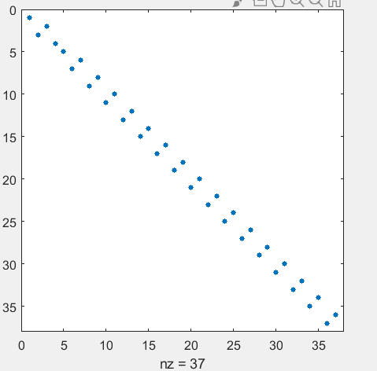

For any, the P matrix looks like this

*Q: What are the lower, upper and total bandwidths of U for any n? Explain. What are the lower, upper and total bandwidths of L for any n?*

As verified using the script, the lower bandwidth of U for any n is 0, the upper is 5 and total is 5+0+1=6. The lower bandwidth of L for any n is 4, the upper is 0 and total is 4+0+1=5. The reason for this is because from theory we know that if A is (l, u) banded, then applying LU factorization will produce L that is (l, 0) banded and U that is (0, u) banded. In this case however, we have partial row pivoting performed as well, so we should get a U that is at most (0, l+u) = (0,4+3) -> (0, 7) banded and an L unit lower triangular that has at most l+1 non zero entries per row. This is in fact the case as seen numerically.

Q: Based on the numerical results, how does the condition number of A behave approximately in terms of n?

|  |  |
| --- | --- |
| n | condest |
| 2 | 17  <-The condition number of A behaved as follows. Once plotted for more and more n, it appeared to be roughly proportional to the square of n |
| 4 | 40 |
| 8 | 93 |
| 16 | 264 |
| 32 | 885 |
| 64 | 3215 |

*Q: Based on the numerical results, how do the values of the top horizontal members’ forces behave as we go from left to right? How do the maximum and minimum values depend on n (approximately)?*

|  |  |  |
| --- | --- | --- |
| n | Max | MIn  Going from left to right, the forces for the horizontal members start at the minimum value and gradually increase to the maximum roughly at about the middle of the bridge after which they decrease back down (but not to the minimum values at the very left of the bridge). Note that all the horizontal forces were positive. The maximum value seems to approximately double from the previous n and I found that it is nicely modeled by the equation 132.25n + 344.67. As for the min value, it seems to be independent of n, always about 670. The shape of the graph of the horizontal forces (left to right) looks like a hump (seen in part a) |
| 2 | 648 | 648 |
| 4 | 840 | 680 |
| 8 | 1400 | 680 |
| 16 | 2468 | 675 |
| 32 | 4565 | 671 |
| 64 | 8807 | 669 |
| 128 | 17276 | 668 |

*Q: Based on the numerical results, how do the values of the diagonal members’ forces behave as we go from left to right? How do the maximum and minimum values depend on n (approximately)?*

Going left to right, the forces of the diagonal members seem to alternate from positive to negative back and forth, all the while decreasing in absolute value to about 0 a bit after the middle of the bridge. After which they start to pick up (in absolute value) in the same fashion of alternating between positive and negative. The maximum value seems to be independent of n (around 700) occurring on the last diagonal member. Same thing for the minimum value, doesn’t seem to depend on n (when it get large enough, about 700 too) occurs on the second last diagonal member

|  |  |  |
| --- | --- | --- |
| n | Max | Min |
| 2 | 731 | -403 |
| 4 | 708 | -479 |
| 8 | 702 | -624 |
| 16 | 702 | -679 |
| 32 | 704 | -697 |
| 64 | 705 | -703 |

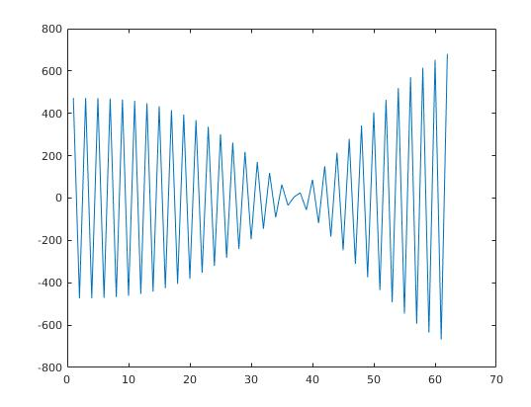

The shape of the graph of the diagonal forces going left to right for n = 64

